## Ideas generation

In the ever-evolving world of interior design, creativity is the cornerstone of success. To create spaces that are functional, aesthetically pleasing, and aligned with clients' visions, interior designers must continuously generate innovative ideas, through the process of Ideas generation.

Idea generation is the process of coming up with new concepts, solutions, and designs. It is a creative activity that taps into brainstorming, research, and experimentation, in order to solve problems or create unique outcomes. For Interior Designers, idea generation involves problem solving of different areas, such as envisioning layouts, selecting colour schemes, identifying materials, and crafting designs that resonate with both practicality and aesthetics.

This skill is not a luxury, it is a necessity. Every project, from a minimalist urban apartment to an opulent hotel lobby, begins with the spark of an idea. For designers, the ability to generate diverse, fresh ideas determines their ability to adapt to trends, meet client expectations, and stand out in a competitive market.

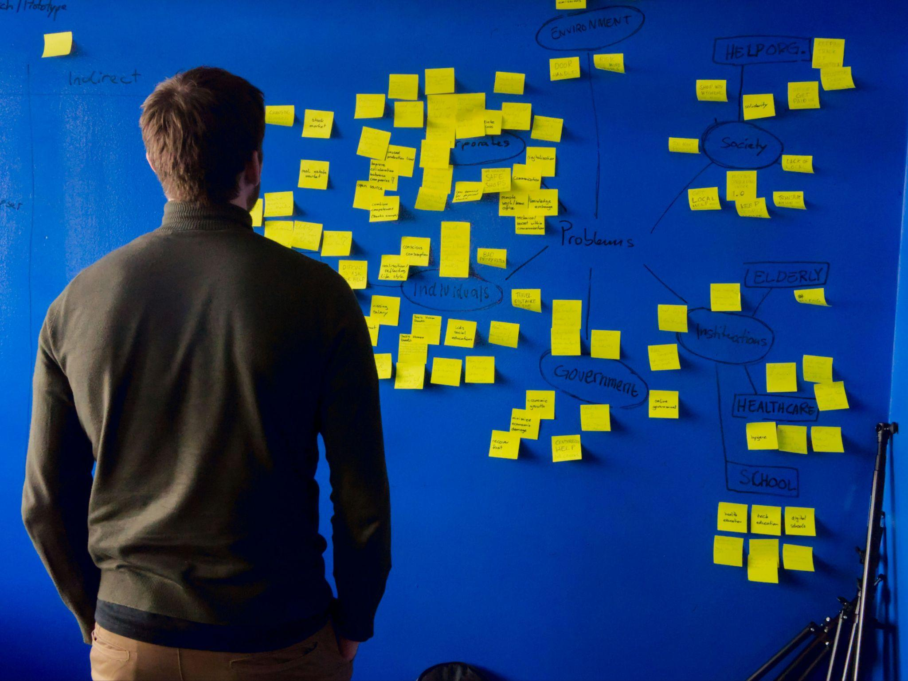

Fig 1. Unsplash (n.d.) Idea generation

The ability to develop your Ideas Generation skills is important for you as an Interior Designer for various reasons. Let us look at these separately:

* Problem Solving: Every design project comes with constraints, such as budget, space limitations, or specific client needs. Generating multiple ideas helps you overcome these challenges with creative solutions.
* Being Innovative: Staying ahead of trends and creating distinctive designs requires out-of-the-box thinking. Fresh ideas will help you innovate and avoid repetition.
* Confidence Building: A robust idea generation process will equip you with a toolkit of concepts, making them more confident when presenting options to clients.
* Developing Collaboration: When working with clients or teams, sharing diverse ideas encourages productive discussions and ensures all perspectives are considered.

### 

### Ideas Generation techniques:

### Sketching and Doodling:

One of the most basic idea generation techniques for a designer is freehand drawing, that allows quick exploration of shapes, layouts, and concepts. Interior designers use sketching and doodling to rapidly sketch different room layouts, furniture ideas, or decorative elements. The key is to keep the sketches loose and spontaneous, in order to generate various concepts quickly. This method works well because sketching frees the mind from constraints, helping to visualize ideas and explore form, space, and proportion.

### Simulation

Simulation is standard practice for many Interior Designers, as this gives them the opportunity to effectively understand their clients and their requirements. Simulation involves putting yourself in the shoes of your client or end-user, so you can simulate real-life scenarios and gain insights, generate ideas, and validate design concepts.



Fig 2. Unsplash (n.d.) VR is a good way to generate simulations

### 3. Collaboration

Working with others in order to generate ideas is a very effective way to look at a project in a holistic manner. Collaboration involves a group activity where multiple designers or stakeholders share ideas and collaborate on concept development. As a designer, you would invite clients, architects, contractors, or other designers to contribute their ideas in an open discussion. During collaboration, participants make use of things like brainstorming boards, sketches, and mock-ups to brainstorm ideas. Collaboration brings multiple perspectives to the table, fostering creativity and encouraging the development of ideas that may not have been considered individually.



Fig 3. Pexels (n.d.) Collaboration

4. Research and Observation

Visiting art galleries, architectural landmarks, or nature reserves ,in order to draw inspiration for either a particular requirement or a general concept for a Design Proposal. During Research and observation, it is important to pay attention to details, such as patterns, textures, and designs, that can be adapted or incorporated into interiors. Studying the work of other designers can also ignite fresh ideas. However, here it is important to make sure that you have a clear understanding of what differentiates your work from the work you have used as inspiration, and that you have not just “copied” it.

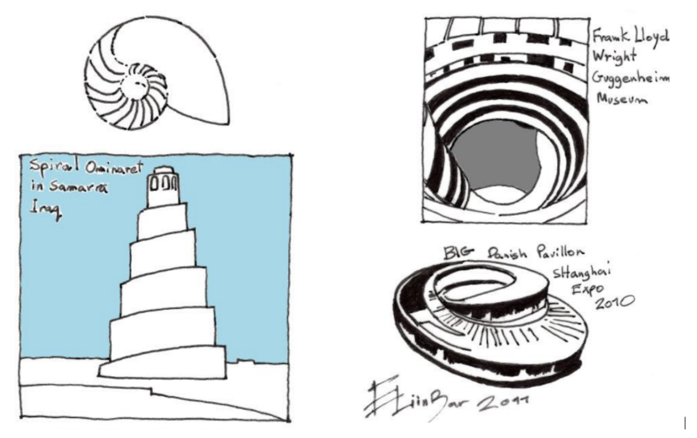

Fig 4. Architecture inspired by a sea shell - two unrelated subjects

### 5. Thinking Hats

The "Thinking Hats" technique, developed by Dr. Edward de Bono, is another powerful tool for facilitating creative thinking, solving problems, and making decisions. This technique encourages designers to approach a problem or situation from different perspectives and put on their proverbial ‘thinking caps’. The six thinking hats represent six metaphorical hats of different colours, each representing a different mode of thinking, allowing participants to explore a problem from multiple angles and generate a variety of ideas.

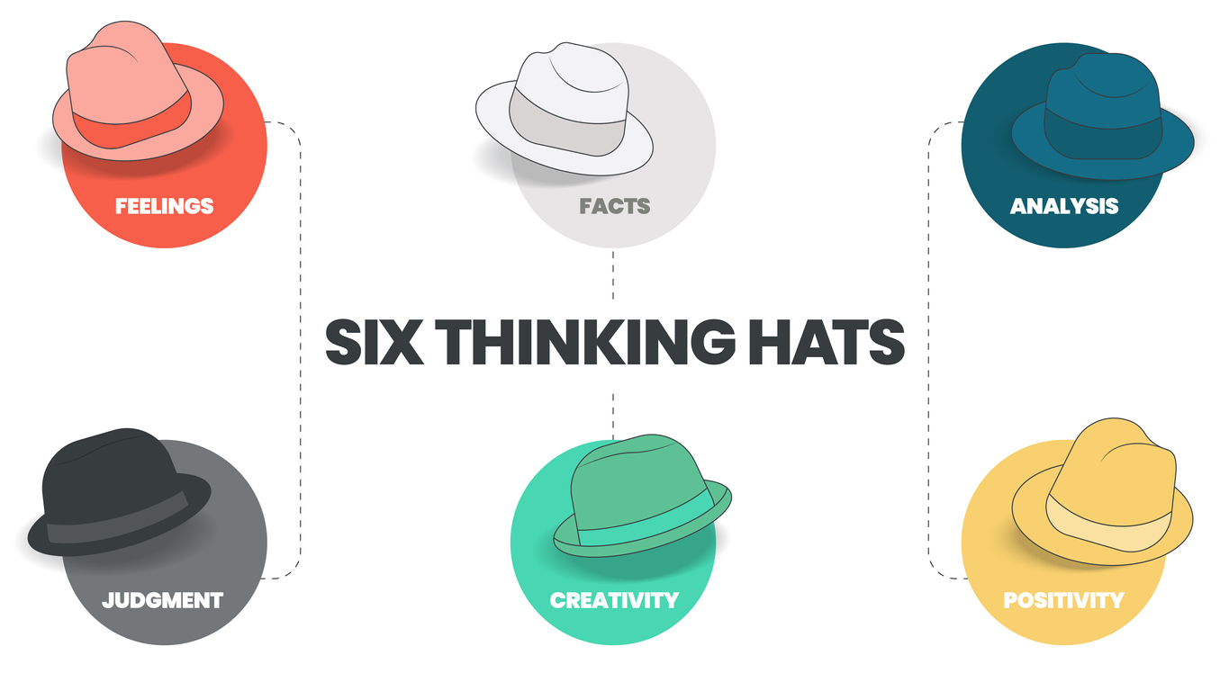

Fig 5. Bono’s Six Thinking Hats

#### White Hat

The White Hat focuses on facts. This is made up of information and data related to the problem or design challenge. They are basically, objective facts. As a designer, when you wear the White Hat, you gather and analyse relevant information, identify gaps in knowledge, and clarify any uncertainties or assumptions. In the design process, the White Hat requires you to gather user research, market data, technical specifications, and other factual information relevant to the project.

#### Red Hat

The Red Hat represents emotions, feelings, and intuition. It allows designers to express their gut reactions, instincts, and emotional responses to a particular problem. When wearing the Red Hat, designers or focus group participants, for example, share their emotional responses without needing to justify or rationalise them. This encourages honesty, empathy, and intuition.

During the design process, the Red Hat can be used to consider how users might emotionally respond to a design solution, identify potential pain points or frustrations, and explore opportunities for creating meaningful connections with users.

#### Black Hat

The Black Hat represents critical thinking, scepticism, and caution. It focuses on identifying potential risks, weaknesses, and obstacles associated with a specific design solution. When wearing the Black Hat, designers analyse the design solution from a very critical perspective, highlighting potential drawbacks, limitations, and areas for improvement. In the design process, you can use the Black Hat to conduct risk assessments, identify potential design flaws or usability issues, and anticipate challenges that may arise during implementation or use.

#### Yellow Hat

The Yellow Hat represents optimism, positivity, and constructive thinking. This ‘hat’ encourages you to focus on identifying opportunities, strengths, and potential benefits associated with a design solution. When wearing the Yellow Hat, designers highlight the positive aspects of the design solution, including its strengths, advantages, and potential value to users and stakeholders. The Yellow Hat is best used to explore opportunities for innovation, to identify strengths and unique selling points of a design solution, and to inspire confidence in its potential success.

#### Green Hat

The Green Hat represents creativity, brainstorming, and ideas generation. It encourages designers to think creatively, and explore new possibilities. When wearing the Green Hat, designers engage in brainstorming sessions, ideation exercises, and creative thinking techniques to generate a wide range of ideas and alternatives. You can also use the Green Hat to explore new design concepts, experiment with different approaches, and push the boundaries of conventional thinking to generate innovative solutions.

#### Blue Hat

The Blue Hat serves as the control hat, overseeing the thinking process and facilitating communication and collaboration among participants or designers. When wearing the Blue Hat, you manage the flow of the discussion, set objectives and agendas, establish ground rules, and guide the group towards achieving its goals. This ‘hat’ is typically worn by a project manager.

In the design process, the Blue Hat can be used to facilitate brainstorming sessions, structure design workshops, manage time and resources effectively, and ensure that the thinking process remains focused and productive.

### 6. Lateral thinking

Lateral thinking, also coined by Edward de Bono, is a creative thinking technique that encourages individuals to approach problems and generate ideas from unconventional perspectives. Strictly speaking, the six Thinking Hats technique is an example of lateral thinking. But there are also other ways to think outside of the box.

Unlike vertical or logical thinking, which follows a linear path of reasoning, lateral thinking involves exploring alternative pathways, making unexpected connections, and challenging assumptions.

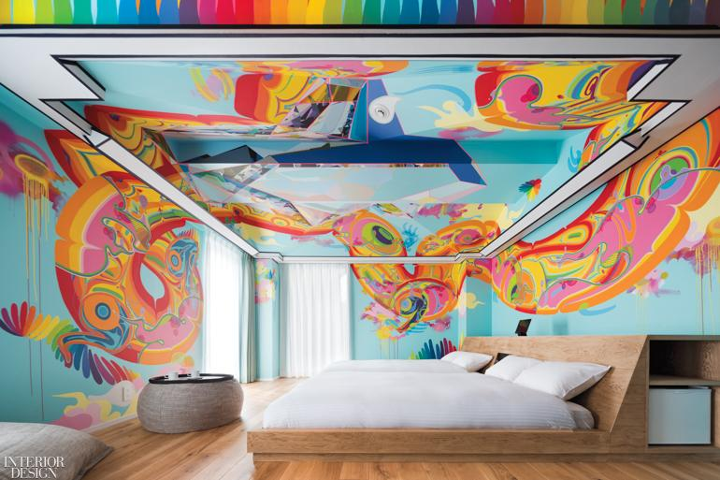

Fig 6. [Interior Design](https://interiordesign.net/projects/10-most-unusual-projects-of-2019/) (2019) Unusual Interior Design Projects

Lateral thinking involves the following:

* **Challenging assumptions and preconceived notions** about the problem or design. By challenging established beliefs and assumptions, you can break free from conventional thinking patterns and explore new possibilities or solutions.
* **Generating and asking provocative questions** to challenge conventional wisdom and stimulate unconventional ideas. For example, instead of asking, "How can we improve the existing design?" you might ask, "What if our design was aimed at a completely different audience or purpose?"
* **Making analogies and metaphors** encourages connections between unrelated concepts, objects, or ideas. Drawing parallels between seemingly disparate elements, allows you to uncover new insights and generate innovative solutions. For instance, you might draw inspiration from nature, music, art, literature, or everyday objects to generate ideas for solving a design problem.
* **Combining ideas, concepts, or techniques from different domains** or disciplines to create novel solutions can create fresh perspectives and innovative approaches to design problems. For example, you might draw inspiration from architecture, biology, psychology, or technology.
* **Using provocative techniques and creativity tools** to stimulate idea generation and problem-solving, such as random stimulation, reversal, exaggeration, and forced connections. This can disrupt conventional thinking patterns and spark creative breakthroughs. For instance, you might use the "random word" technique, where you randomly select a word and brainstorm ideas based on associations with that word, that might generate solutions to a design challenge.
* **Encouraging playfulness and experimentation** allows you to feel free to explore unconventional ideas and take risks. By embracing ambiguity, uncertainty, and failure, you can discover unexpected solutions and discoveries. You might engage in activities such as doodling, sketching, role-playing, or improvisation to stimulate creativity and generate new ideas.

In the dynamic field of interior design, the ability to consistently generate fresh, innovative ideas is not just a desirable trait—it's essential. From sketching and simulation to collaborative brainstorming and lateral thinking, a wide array of techniques empowers designers to approach challenges creatively and thoughtfully. Tools like the Six Thinking Hats and immersive research practices encourage deeper understanding, emotional insight, and out-of-the-box solutions. By mastering and continually refining idea generation skills, interior designers can not only meet the functional and aesthetic needs of their clients, but also elevate their work to stand out in a competitive industry. Ultimately, idea generation fuels the imagination and drives the evolution of interior spaces into meaningful, inspired environments.